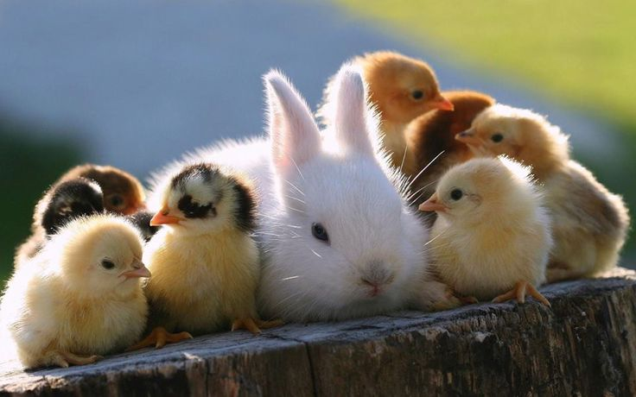
Gates County 4-H
Chicken & Rabbit Show

Purpose: The 4-H Chicken and Rabbit Show is designed to be a fun and educational project for youth 5 – 18 years of age. The 4-H Chicken and Poultry projects give youth a chance to participate in a smaller scale animal science project. This project will teach youth responsibility, time management, leadership skills, record keeping, public speaking and workforce development skills.

Rules: All youth must register through the 4-H office by completing an entry form and submitting the entry fee. The entry fee is $10.00 per species. A child can show both a rabbit and a chicken the entry fee would be $20.00.

The 4-H office will order chicks and each chicken show participant will receive 3 chicks. You will need to come to the 4-H office to pick up your chicks the day they arrive at the 4-H office. You will only show one chicken.

Rabbit show participants will be required to find their own rabbit. The 4-H office can help you find a rabbit breeder if you need help. Rabbits must be under one year of age by show date.

Youth will be divided into three age categories based on your 4-H age (age as of January 1) Cloverbud (5-8 year olds), Junior (9-12 year olds), and Senior (13 -18 year olds). Cloverbud youth will only show in a showmanship category and will be participation only. Junior and Senior youth will compete in showmanship categories and a meat breed category.

All youth participating in this project will be required to turn in a 4-H project record book. The project record book will be due the day of the show at check in. If you do not turn in a project record book you will not be allowed to show. This project is designed to be educational and fun. The project record book will help reinforce what the youth are learning throughout the project.

The deadline to register for the 4-H Chicken and Rabbit Show is Monday, April 30, 2018. All paper work (4-H enrollment form, medical, and entry form) must be completed and entry fee paid Monday, April 30, 2018.

Show date is scheduled for Tuesday, October 9, 2018 at 6:00pm. The location will be at the Gates County Cooperative Extension office.

